YEAR 11 CHEMISTRY
AECHE
Unit 2

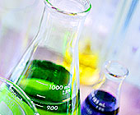

Solutions

PROPERTIES OF WATER

NC p59, 63, 65, 67, 70, 71

- A large number of the reactions studied in chemistry occur in solution.

- In most of these cases, water is the solvent in these solutions.

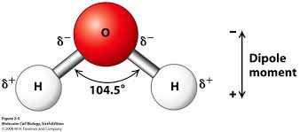
- The chemical structure of water is what gives it the particular properties that make it the “universal solvent”

Chemical Structure

- Water is a bent, asymmetrical molecule containing intramolecular covalent bonds.
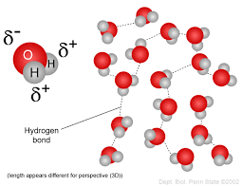
- Each of the OH bonds is highly polar, giving water the ability to form intermolcular hydrogen bonding forces.

Properties of water

- Water has a number of unusual properties for such a small covalent molecule.
- These properties result from the hydrogen bonding forces between adjacent water molecules.

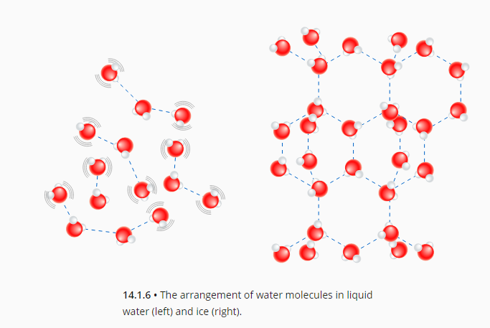
- High melting point and boiling – takes a significant amount of energy to overcome the hydrogen bonding forces during changes of state.

- Expands upon freezing – due to the crystal structure that results from the arrangement of dipoles in the solid.

- High surface tension – due to strength of hydrogen bonding forces between water molecules at the surface and the molecules adjacent to them.

- High latent heat of vaporisation and fusion – energy required to change state completely at the boiling/freezing point. Due to strength of hydrogen bonding forces.

- High heat capacity – ability to absorb and store heat energy. Due to ability of hydrogen bonds to absorb/store energy.

NC 6.1 p258, 6.5 p269-72
EC 15.9 p133

SOLUTIONS

Solubility

- General Definitions:
- Solution - homogeneous mixtures – made up of a solute and a solvent.
- Solvent – ‘does the dissolving’ – usually a liquid.
- Solute – ‘is dissolved’ – usually the solid.
For example: When sugar dissolves in water, solvent is the water and sugar is the solute.
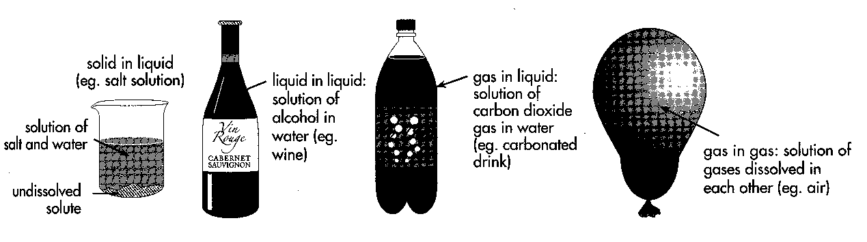
- Saturated solution – one in which no more solute will dissolve under existing conditions of temperature and pressure.
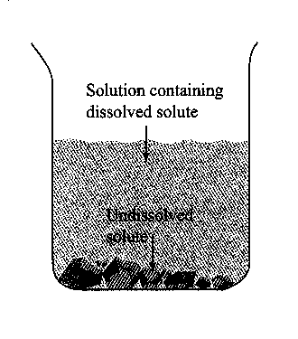
- Unsaturated solution – a solution which contains less than the quantity of solute needed to saturate it under existing conditions of temperature and pressure.
- Supersaturated solution – solution which contains more solute than a saturated solution could normally hold under the existing conditions.
- Solubility – the degree to which a solute dissolves in a solvent.
- Dilute – contains very little solute in relation to the amount of solvent.
- Concentrated – contains a large amount of solute in relation to the amount of solvent.
- Concentration – refers to the amount of solute dissolved in a certain amount of solvent.

- PROBLEM SET – Answers p 33
- The solubility of NaCl is 36 g per 100 g of water at 25⁰C. Which of the following solutions are saturated, unsaturated or supersaturated?

  - 30 g NaCl in 100 g of H₂O
  - 38 g NaCl in 100 g of H₂O
  - 36 g NaCl in 100 g of H₂O
  - 20 g NaCl in 50 g of H₂O
  - 9 g NaCl in 25 g of H₂O
  - 25 g NaCl in 80 g of H₂O
- If the solubility of NiSO₄.7H₂O is 41 grams per 100 grams of water at 25⁰C, how might it be possible to prepare a supersaturated solution containing 43 g per 100 g of water?

- A student is given an aqueous solution of a salt and a crystal of salt. How could the student determine whether the solution is unsaturated, saturated or supersaturated?

Formation of solutions

- Solutions are homgenous mixtures – the solvent and solute are uniformly distributed and indistinguishable from one another.
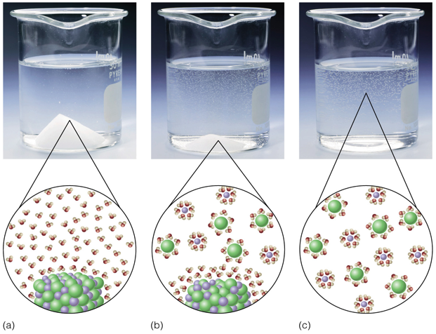
- When a substance dissolves, solute particles separate from one another, solvent particles separate from one another and the solute and solvent particles become attracted to each other.

- For a substance to dissolve, the attraction between solute and solvent particles must be stronger than the attraction between particles within the solvent and within the solute.

- Substances are more likely to dissolve if their particles can better interact with the solvent molecules.
- This explains the 'like dissolves like' phenomenon.
Types of solute-solvent forces in aqueous soluitons.

- Hydrogen bonding forces between water molecules and solutes that are covalent molecular compounds with H-O/F/N bonds.

- Ion-dipole forces between water molecules and covalent molecular solutes that ionise when they dissolve, due to water removing a hydrogen atom from the solute molecule – hydrogen chloride will ionise when it dissolves, forming hydronium (H₃O⁺) and chloride ions (Cl⁻).

- Ion-dipole forces between water molecules and ionic substances that dissociate when they dissolve

- Note: Ionising is when a substance forms ions when it dissolves. Dissociating is when the ions that already existed in the lattice separate from each other

EC 16.1 p138
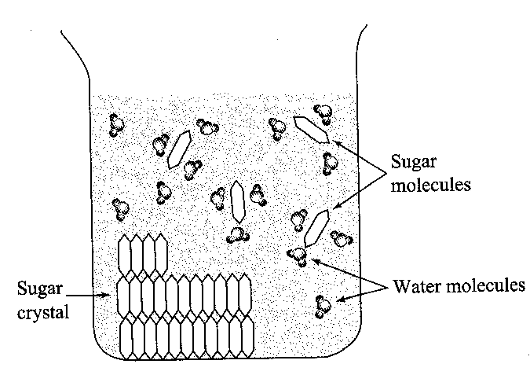
The Solution Process And Factors Affecting Solubility

- For Sugar to dissolve in water the following must take place:
- Intermolecular forces between the sugar molecules (dipole-dipole forces) must be overcome as the crystals dissolve.
- The intermolecular forces between some water molecules (hydrogen bond forces) must be overcome to make room for the sugar molecules.
- Intermolecular forces (dipole-dipole forces) must form between sugar molecules and surrounding water molecules.
- Intermolecular forces are forces of electrostatic attraction between molecules.

Nature of the solute and solvent

- In general, solute will dissolve in a solvent only if:
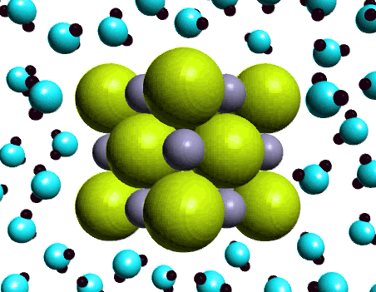
- Intermolecular forces within the solute and those within the solvent are similar to those occurring between solute and solvent molecules.
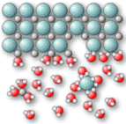
Insoluble – intermolecular forces are too weak to pull the solid apart

Soluble – intermolecular forces are strong enough to pull the solid apart

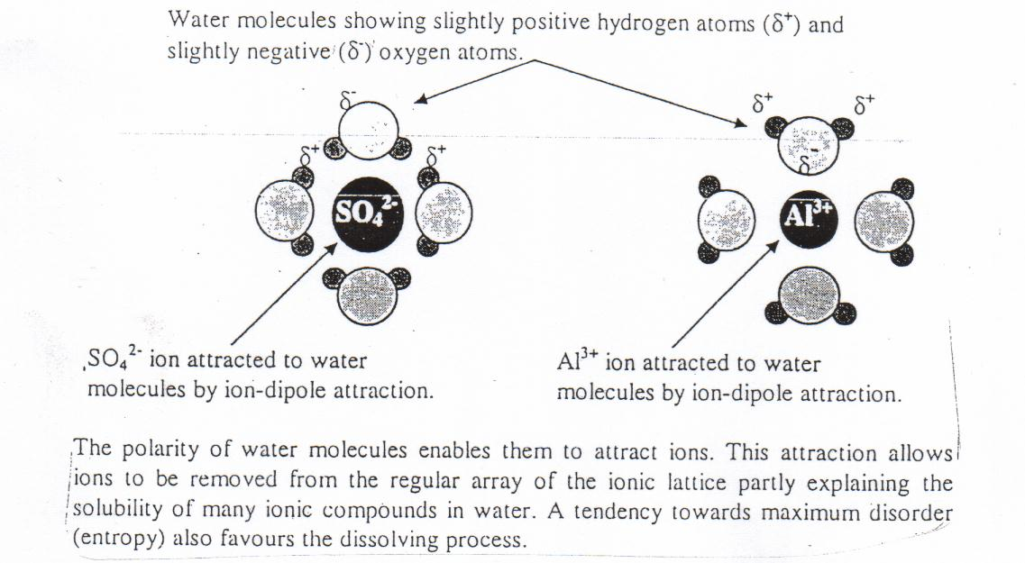
- Polar solvents tend to dissolve polar solutes and non-polar solvents tend to dissolve non-polar solutes.

- Dissociation of ionic compounds is due to the polar nature of water molecules.
- The polarity of water molecules enables them to attract ions. This attraction allows ions to be removed from the regular array of the ionic lattice partly explaining the solubility of many ionic compounds in water.

    - Why does oil not dissolve in water?

- Oil will dissolve in non-polar solvents such as kerosene because suitable intermolecular forces exist between the oil and kerosene molecules.

Some ionic compounds dissolve in water and others do not because some ionic compounds are very stable – that is the force holding their ions in their crystal lattice are very strong.
Readily soluble in water (polar) |  | Readily soluble in CCl₄ (non-polar)
NH_{3 (g)} |  | CH_{4 (g)}
CH₃OH_{(l)} |  | C₈H_{18 (l)}

NC 6.6 p275-8 QS 6.4 p278-9 EC 16.4 p140
Temperature

- An increase in temperature usually results in an increase in solubility.
- The solubility of gases when dissolved in a liquid decreases with increasing temperature.

Use the following data to plot solubility curves for the substances listed.

Temperature °C |  | 0 | 20 | 40 | 60 | 80
Solubility (gL⁻¹) | KNO₃ | 150 | 320 | 610 | 1020 | 1700
 | NH₃ | 900 | 530 | 320 | 170 | 65


Solubility (gL⁻¹)
10 20 30 40 50 60 70 80 90
Temperature (°C)

1000

900

800

700

600

500

400

300

200

100

- In general, what effect does increasing the temperature of a solution have on the solubility?

- If a beaker of water at room temperature is heated, bubbles of gas form on the sides of the beaker, well below the water’s boiling point. What are these bubbles likely to be?

NC 6.7 p279-84 QS 6.5 p285 (don’t need to do # 4, 7, 9 yet)
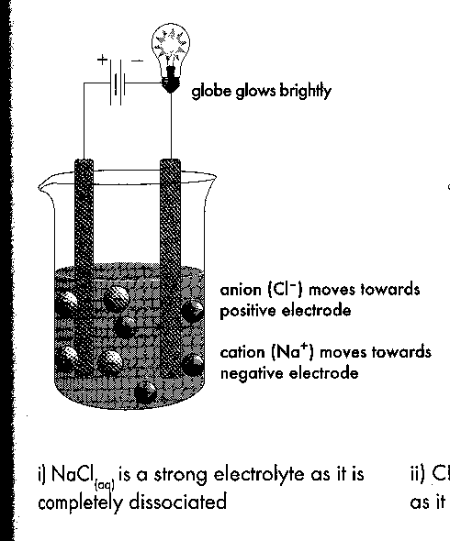
Aqueous Solutions And Electrolytes

- Aqueous solutions – solutions in which the solute dissolves in water –
denoted by symbol (aq).
- Electrolytes are those substances that dissolve in water producing ions.
- They are classified according to the extent to which they produce ions
when dissolved in water.

Strong Electrolytes:
- Entirely or mostly present as ions when dissolved.
- all soluble ionic compounds such as sodium chloride, calcium chloride, potassium carbonate, potassium nitrate, sodium carbonate and iron (II) sulphate.
NaCl _{(s)} → Na⁺ _{(aq)} + Cl⁻_{(aq)}
- Certain covalent molecular substances – HCl, H₂SO₄, HNO₃, HClO₄ and HBr – strong acids.
HCl_{(g)} → H⁺_{(aq)} + Cl⁻_{(aq)}
- All strong electrolytes dissolve to form ions only.
- All ionic compounds are strong electrolytes (even insoluble ionic compounds – the small portion that does dissolve will totally dissociate, producing a small number of ions in solution).
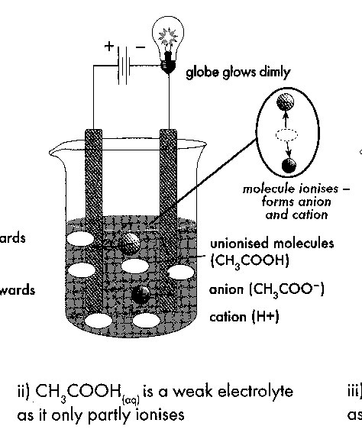

Weak Electrolytes
- Partly present as ions when dissolved – covalent molecular substances.
- Weak acids or bases – H₂SO₃, H₃PO₄, CH₃COOH, H₂CO₃, HF and NH₃.
CH₃COOH_{(l)} ⇋ CH₃COO⁻_{(aq)} + H⁺_{(aq)}
- Dissolve mainly forming molecules with a much lower concentration of ions.

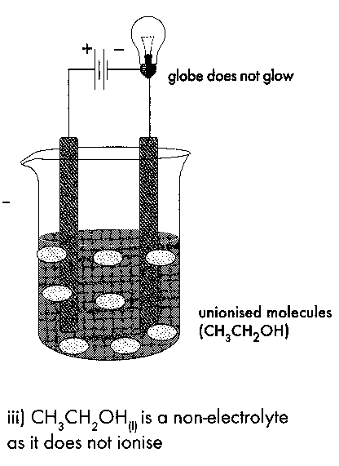

Non-electrolyte:
- Produce no ions when dissolved – covalent molecular substances.
- Not acidic or basic – CH₄, C₈H₁₈, C₂H₅OH, C₁₂H₂₂O₁₁ (sucrose), and C₆H₁₂O₆ (glucose)
- Produce only molecules when dissolved in water.

- An electrolyte will increase a solution’s electrical conductivity.
- This is due to the mobile ions releases from the electrolyte.
- These ions act as charge carriers.

- A solutions electrical conductivity increases with increasing ion concentration.
- This in turns increases the electrolyte strength and concentration.

Conductivity of electrolyte solutions:

Nature of Electrolyte | Conductivity of Solutions
Soluble strong electrolyte | High conductivity – increases with solution concentration.
Insoluble strong electrolyte | Very low conductivity – increases with solubility of electrolyte
Soluble weak electrolyte | Low conductivity – increases with solution concentration but always remains low
Soluble  non-electrolyte | Non conducting – does not change with solution concentration

EC 16.2 p138-9
DISSOCIATION AND IONISATION REACTIONS

- Dissociation:
- Ionic compounds dissociated into their ions when they dissolve in water:
NaCl_{(s)} → Na⁺_{(aq)} + Cl⁻_{(aq)}
- This is known as a dissociation reaction – the ions in the ionic solid have been separated in the solution/dissolving process.
- Evidence for the dissociation of NaCl is provided by conductivity measurements:
- A solvent (e.g. distilled waer) which does not contain ions does not conduct electritity.
- An aqueous solution of NaCl is a good conductor of electritity – the Na⁺ and Cl⁻ ions move through the solution when an electric current flows through it.
- CATIONS (positive ions) – attracted to the negative terminal of power pack (ANODE)
- ANIONS (negative ions) attracted to the positive terminal of power pack (CATHODE)
NC 7.1 p304

- Ionisation:
- Covalent molecular substances such as strong acids undergo ionisation reactons when they dissolve in water.
HCl_{(g)} → H⁺_{(aq)} + Cl⁻_{(aq)}
- Weak covalent molecular substances show both ions and molecular substance present in solution:
HF_{(aq)} → H⁺_{(aq)} + F⁻_{(aq)}

- The difference between ionisation and dissociation:
- Dissociation – ions that are already present in the solid are separated and move into solution.
- Ionisation – covalent molecular substances react to form ions which are separated in solution.

EC 16.3 p139

GENERAL SUMMARY
Substance

COVALENT
Non-metal+non-metal
IONIC
Metal+non-metal

Non-acid
Insoluble
Acid
Soluble

Weak acid
Strong acid

Dissociation Dissociation

Complete Incomplete
Ionisation Ionisation

Non electrolyte
No conductivity
Weak electrolyte
Low conductivity
Strong electrolyte
High conductivity
Strong electrolyte
Low conductivity
Strong electrolyte
High conductivity

PROBLEM SET – Answers p 33
- Write dissociation equations for the following ionic solids (balance equations):
  - Potassium chloride
  - Calcium nitrate
  - Silver chloride
  - Iron (II) nitrate
  - Magnesium bromide
  - Iron (III) sulfate
  - Ammonium Ferrous Sulfate
  - aluminium sulfate
- Where necessary, write the formula then classify the following substances as strong, weak or non-electrolytes:
  - magnesium nitrate
  - ammonia gas
  - Benzene: C₆H₆
  - Lithium hydroxide
  - Ethanoic acid: CH₃COOH
  - Ammonium chloride
- Predict the electrical conductivities as high, low or zero for aqueous solutions of the following:
  - potassium sulfate:
  - HI
  - Methanol: CH₃OH
  - NaOH
  - Ammonia
  - Glucose: C₆H₁₂O₆
  - BaSO₄ (virtually insoluble)
  - CH₃COOH (ethanoic acid)
- The following molecular substances are all strong electrolytes. Write an ionisation equation showing how each of these dissolves in water to produce ions.

  - HCl_{(g)} →
  - HNO_{3(l)} →
  - HClO_{4(l)} →
  - H₂SO_{4(l)} → or H₂SO_{4(l)} →
  - HBr(g) →
- Write an ionisation equation for the following molecular substances, all of which are weak electrolytes. Your equation should indicate that molecules and ions are both present.

  - HF
  - H₂SO₃
  - Oxalic acid: H₂C₂O₄
  - Nitrous acid: HNO₂

- A range of strong electrolytes, weak electrolytes and non-electrolytes are listed below. Solutions of these compounds are made by dissolving a sample of each in water. If ions are produced, write an appropriate equation to show this. If the substance dissolves without producing ions write “no reaction”.
  - sodium hydroxide
  - ethanoic acid
  - copper (II) ethanoate
  - ethanol (C₂H₅OH)
  - iron (III) chloride
  - sucrose (C₁₂H₂₂O₁₁)
  - ethane (CH₄)
  - hydrogen sulfide
  - chloroform (CHCl₃)
  - potassium dichromate
  - nitric acid
  - calcium hydroxide
  - ammonium sulfate

- Use your understanding of electrolytes and their properties to account for the following:
  - A solution of hydrogen chloride dissolved in water contains very few HCl_{(aq)} molecules, even though HCl_{(g)} is composed entirely of molecules

  - Both NaCl_{(s)} and NaCl _{(aq)} contain ions, yet NaCl _{(s)} is a poor conductor of electricity while NaCl _{(aq)} is a good conductor of electricity.

  - A solution of hydrogen chloride is a much better conductor of electricity than a solution of hydrogen fluoride of the same concentration.

  - Despite AgCl being a strong electrolyte, its solution can never contain a high concentration of Ag⁺_{(aq)} and Cl⁻_{(aq)} ions.

- A solution of Cu(NO₃)₂ contains no particles of formula Cu(NO₃)_{2(aq)}.

- Both NH₃ _{(aq)} and CH₃COOH_{(aq)} are poor electrolytes and neither solution is a good electrical conductor, yet when the two solutions are combined the resulting mixture has a very high electrical conductivity.

Solubility Rules And Precipitation Reactions
- A precipitation reaction occurs when an insoluble solid forms within a previously clear solution.
- Precipitation will happen if any pair of oppositely charged ions present in a solution combine and form an insoluble compound.
- This will happen when two solutions containing different ions are combined and mixed.

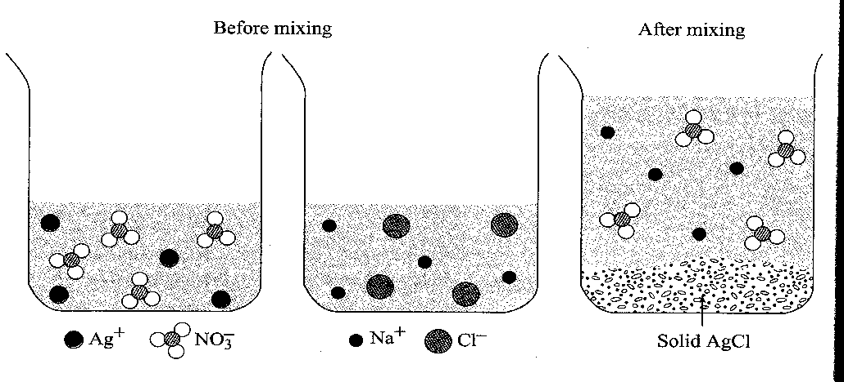
Example:
Solutions of AgNO_{3 (aq)} and NaCl_{(aq)} are combined and mixed. Will a precipitate form? If so, give its formula. All solution concentrations are 1.0 mol L⁻¹.

- Identify and list all ions present in the combined mixture of the two solutions.

Ag⁺_{(aq)} NO₃⁻_{(aq)} Na⁺_{(aq)} Cl⁻_{(aq)}

- Write the formula for possible precipitates by combing oppositely charged ions.

AgCl or NaNO₃


- Refer to the solubility rules and determine the solubility of these substances. One is given on the next page but you must learn to use the one on your data table as this is the one in your tests. Any low or slightly solubility compound can be expected to form a precipitate.

NaNO₃ is soluble (all nitrates are) so the only solid formed is AgCl _{(s)}

- Write a balanced equation to summarise the change. Only include the ions that form the precipitate.

Ag⁺_{(aq)} + Cl⁻ _{(aq)} → AgCl_{(s)}

Solubility rules for ionic solids in water:

Soluble in water | Exceptions
 | Insoluble | Slightly soluble
Most chlorides | AgCl, Hg₂Cl₂ | PbCl₂
Most bromides | AgBr, Hg₂Br₂, HgBr₂ | PbBr₂
Most iodides | AgI, Hg₂I₂, HgI₂, PbI₂
All nitrates | Nil
Most sulfates | SrSO₄, BaSO₄, HgSO₄, PbSO₄ | CaSO₄, Ag₂SO₄

Insoluble in water | Exceptions
 | Soluble | Slightly soluble
Most hydroxides | NaOH, KOH, Ba(OH) ₂  (NH₄OH does not exist) | Ca(OH) ₂, Sr(OH) ₂
Most carbonates | Na₂CO₃, K₂CO₃, (NH₄) ₂CO₃
Most phosphates | Na₃PO₄, K₃PO₄, (NH₄) ₃PO₄
Most sulfides | Na₂S, K₂S, (NH₄) ₂S

Soluble = more than 0.1 mole dissolves per litre
Slightly soluble = between 0.01 and 0.1 mole dissolves per litre
Insoluble = less than 0.01 mole dissolves per litre
QUICK REFERENCE
- The following are Cations (positive ions) which are always soluble when they combine to make a salt.
- Group one metals – Li, Na, K, Rb, Cs, Fr
- H⁺
- NH₄⁺

Colours of aqueous ions of selected transition elements

Chemistry data sheets provide information about colours of ions and ionic solids.
Otherwise:
- It is acceptable to infer the colour of the solid from the colour of the constituent ions.
- It is acceptable to assumes that a white solid forms from colourless ions.

- When two solutions, such as silver nitrate solution and sodium chloride solution are mixed, a precipitate of silver chloride will form.

Ag⁺_{(aq)} + NO₃⁻_{(aq)} + Na⁺_{(aq)} + Cl⁻_{(aq)} AgCl _{(s)} + Na⁺_{(aq)} + NO₃⁻_{(aq)}
- This reaction occurs due to the silver ion and chloride ions. The nitrate ion and sodium ions are not involved in this reaction as shown by the fact that they are the same on both sides of the reaction. These ions are called “spectator ions” and are not included in the final equation.
- An equation that shows only the species that react is called an ionic equation.
- An ionic equation for the reaction discussed above:
AgNO₃ _{(aq)} + NaCl _{(aq)} AgCl _{(s)} + NaNO₃ _{(aq)} Molecular equation
Ag⁺ _{(aq)} + NO₃⁻ _{(aq)} + Na⁺ _{(aq)} + Cl⁻ _{(aq)} AgCl _{(s)} + Na⁺ _{(aq)} + NO₃⁻ _{(aq)} Spectator ions
Ag⁺ _{(aq)} + Cl⁻ _{(aq)} AgCl _{(s)} Net Ionic equation
- An ionic equation is the most accurate way of representing what occurs when the reaction takes place.
  - An ionic equation is the most accurate way of representing what occurs when the reaction takes place.
  - Ionic equations can be used for reactions other than precipitation reactions. However, they are mainly used for reactions which take place in solution.
- When writing ionic equations the following rules should be observed:
- Strong electrolytes are written in ionic form e.g. Na⁺_{(aq)} (Use )
- Weak electrolytes are written in molecular form e.g. NH_{3(g)} (Use ⇋)
- Non-electrolytes are written in molecular form e.g. C₆H₁₂O₆
- Insoluble substances are written as the formulas of the substances e.g. Zn(OH)_{2 (s)}
- Gases are written in molecular form e.g. H_{2 (g)}
- Ionic equations should not include spectator ions.
- Equations must be balanced in atoms and electrical charge.
Example 1:
Write an ionic equation which shows the preparation of carbon dioxide gas by the reaction of sodium carbonate solution with hydrochloric acid.

The full molecular equation is: Na₂CO_{3 (aq)} + 2HCl_{(aq)} → 2NaCl _{(aq)} + CO_{2 (g)} + H₂O _{(l)}
However an ionic equation gives shows us the actual reactions taking place and should be used instead.
Checking the solubility tables we can determine the solid produced and the ions in solution:

2Na⁺_{(aq)} + CO₃²⁻_{(aq)} + 2H⁺_{(aq)} + 2Cl⁻_{(aq)} → 2Na⁺_{(aq)} + 2Cl⁻_{(aq)} + CO_{2 (g)} + H₂O _{(l)}
It can be seen that the spectator ions are Na⁺_{(aq)} and Cl⁻_{(aq)} and these take no part in the reaction so are removed.

The net ionic equation is: CO₃²⁻ _{(aq)} + 2H⁺_{(aq)} CO_{2 (g)} + H₂O_{(l)}

- NOTE: Depending on whether the acid is added to a solid carbonate or a solution containing carbonate ions, the ionic equation can be written as follows: (This is the case for all substances.)

Acid + solid carbonate:
Na₂CO_{3 (s)} + 2H⁺_{(aq)} 2Na⁺_{(aq)} + CO_{2 (g)} + H₂O_{(l)}

Acid + carbonate in solution (cation does not form a ppt):
CO₃²⁻ _{(aq)} + 2H⁺_{(aq)} CO_{2 (g)} + H₂O_{(l)}

Example 2:
Write an ionic equation for the preparation of hydrogen gas by the reaction of zinc metal with an acid.

Note: All acids have hydrogen ions so it doesn’t matter which acid is used as the reaction is only concerned with the hydrogen ion as shown below.

For strong acids we use the hydrogen ion because it will ionise fully.

Zn_{(s)} + 2H⁺_{(aq)} Zn²⁺_{(aq)} + H_{2 (g)}

For weak acids we keep the them as a molecule.

Zn_{(s)} + H₂CO₃ _{(aq)} Zn²⁺_{(aq)} + CO₃²⁻_{(aq)} + H_{2 (g)}

- Write the equation for any precipitate formed from the following reactions:

Aluminium chloride solution is added to sodium hydroxide solution to form solid aluminium hydroxide

A mixture of iron (III) chloride and potassium carbonate solutions.

Potassium carbonate solution is mixed with barium chloride solution.

NC 7.1 p304-10 QS 7.1 p311
EC 16.5, 16.6 p142-3
Summary
- Complete ionic equations: show all chemicals that exist as ions in solution as ions. These equations reflect all of the ions shown in a normal equation. Only aqueous chemicals are shown as ions!

Molecular equation: Li₂SO₄ (aq) + Ba(NO₃)₂ (aq) 2 LiNO₃ (aq) + BaSO₄ (s)
Complete ionic equation:
2 Li⁺ (aq) + SO₄²⁻ (aq) + Ba²⁺ (aq) + 2 NO₃⁻ (aq) BaSO₄ (s) + 2 Li⁺ (aq) + 2 NO₃⁻ (aq)
- Spectator ions: Sometimes a complete ionic equation shows ions that are unchanged by the reaction. These ions are known as spectator ions. In the above example both lithium ions and nitrate ions are spectators because the terms 2 Li⁺ (aq) and 2 NO₃⁻ (aq) appear unchanged on both sides of the equation.

Complete ionic equation with spectator ions circled:

2 Li⁺ (aq) + SO₄²⁻ (aq) + Ba²⁺ (aq) + 2 NO₃⁻ (aq) BaSO₄ (s) + 2 Li⁺ (aq) + 2 NO₃⁻ (aq)

- Net ionic equations: When the spectator ions are cancelled out of a complete ionic equation, the equation is greatly simplified! This is known as a net ionic equation.

For the above example the net ionic equation is: Ba²⁺ (aq) + SO₄²⁻ (aq) BaSO₄ (s)

- Like regular equations, ionic equations are balanced for atoms and also for charge!

- For each equation, write the complete ionic equation first, then the net ionic equation.

Ba(ClO₃)₂ (aq) + Na₂S (aq) BaS (s) + 2 NaClO₃ (aq)

2 Na₃PO₄ (aq) + 3 ZnSO₄ (aq) 3 Na₂SO₄ (aq) + Zn₃(PO₄)₂ (s)

SnCl₄ (aq) + 2 (NH₄)₂S (aq) 4 NH₄Cl (aq) + SnS₂ (s)

- Write a balanced net ionic equation for the reaction that occurs in each of the following.
Assume that all soluble reactants are added in the form of aqueous solutions.
Indicate gases and precipitates that are formed, as well as insoluble solid reactants.
If no reaction occurs, then write "NR" and do not write a balanced equation,

- potassium phosphate + magnesium nitrate → potassium nitrate + magnesium phosphate(solid)

- sodium hydroxide + oxalic acid → sodium oxalate + water

- calcium + iron (III) sulfate → calcium sulphate(solid) + iron

- calcium carbonate(solid) + sulfuric acid → calcium sulphate(solid) + carbon dioxide gas + water

- ammonia solution + sulfuric acid → ammonium sulphate solution

- sodium sulphide solution + phosphoric acid → sodium phosphate solution + hydrogen sulphide gas

- zinc + copper (II) chloride → zinc chloride + copper

- barium chloride + sulfuric acid → barium sulphate(solid) + hydrogen chloride solution

- sodium sulfite + hydrochloric acid → sodium chloride + water + sulphur dioxide gas

PROBLEM SET – Answers p 35
- Nathan and Simon carried out several experiments to see if a precipitate formed. The solutions they mixed are listed below. In which experiments do you think they should observe a precipitate? If a precipitate is formed, give its formula.

  - Zinc nitrate solution and sodium carbonate solution
  - Iron (II) chloride solution and potassium hydroxide solution
  - Ammonium sulfate solution and magnesium chloride solution
  - Sodium chloride solution and lead (II) nitrate solution
  - Calcium nitrate solution and sodium sulfate solution
  - Barium chloride solution and potassium sulfate solution

- Each of the following substances has been produced using a precipitation reaction. For each substance write a net ionic equation that shows this:

  - AgBr
  - PbSO₄
  - Calcium phosphate
  - Zn(OH)₂
  - Fe₂(CO₃)₃
  - Zinc chromate

- In a series of experiments the following observations were made. Unfortunately, the student recording these results didn’t record which combination of reactants produced each result. The reagents and observations are listed below. What is the most likely combination of reagents responsible for each observation? Name two reagents from this list that could have produced each observed result.

CoCl_{2 (aq)}; CuSO_{4 (aq)}; Pb(NO₃)_{2 (aq)}; Cr₂(SO₄)_{3 (aq)}; FeCl_{3 (aq)}; Na₂CO_{3 (aq);} MgI₂ _{(aq)}; FeSO_{4 (aq)}
Start by identifying the colours of the solutions listed and writing it under the formula.

Use the following table to help identify the precipitates.
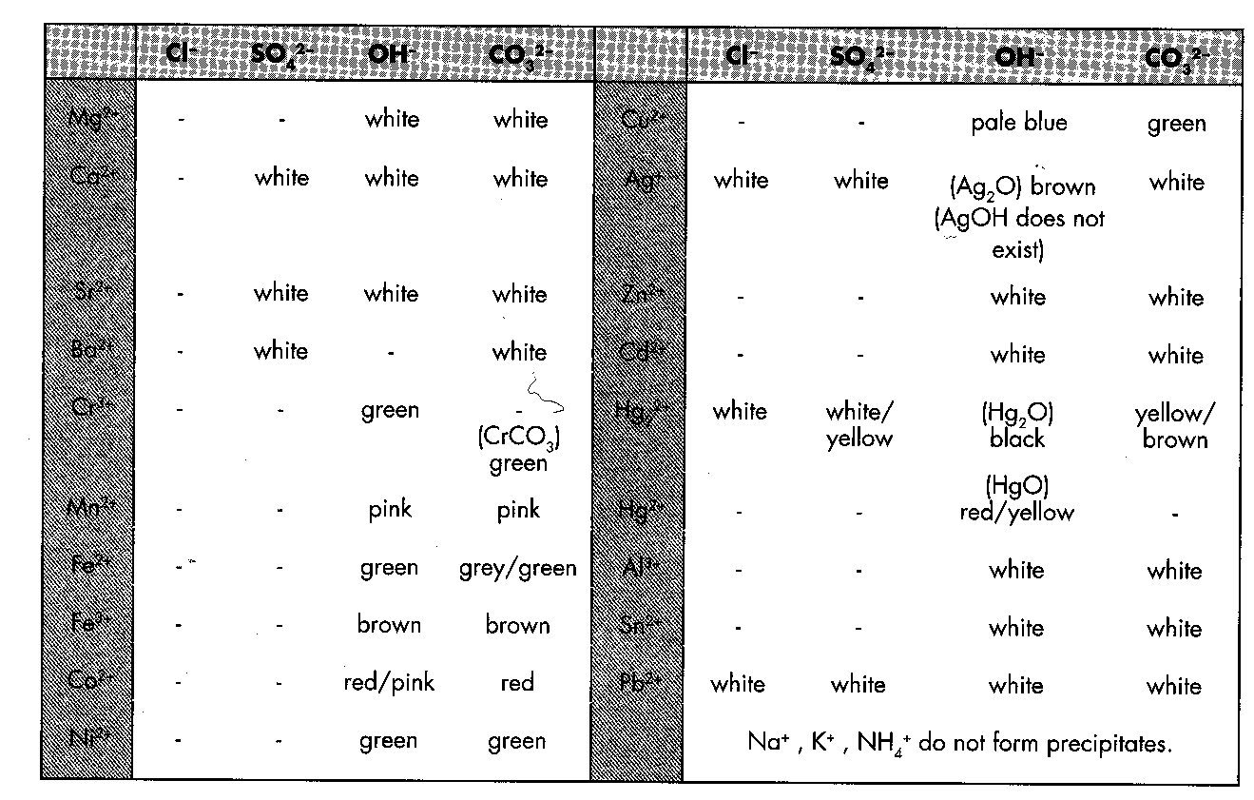
PbI₂ is yellow.

  - A brown precipitate forms when a pale brown solution is mixed with a colourless solution.

  - A white precipitate is produced from two clear colourless solutions

  - A colourless and a pale green solution are mixed and turn cloudy as a pale green precipitate forms.

  - A clear blue solution and a colourless solution produced a green precipitate.

  - A bright yellow precipitate is formed from two clear colourless solutions.

  - A pink solution and a clear colourless solution are mixed producing a red precipitate.

- Tiahn and Niamh perform the following series of experiments. In which do you expect they will observe a precipitation reactions? Where a reaction occurs, write a net ionic equation to show this and give an expected observation.

e.g. A solution of K₂CO₃ is mixed with a solution of silver nitrate.
Precipitation reaction? Yes
Ionic equation: 2Ag⁺_{(aq)} + CO₃²⁻_{(aq)} Ag₂CO_{3(s)}
Observation: two colourless solutions are mixed to produce a yellow precipitate and a colourless solution

  - A Na₂CO₃ solution is mixed with a CaCl₂ solution.
Precipitation reaction?
Ionic equation:
Observation:

  - KBr_{(aq)} and NaOH_{(aq)} are mixed.
Precipitation reaction?
Observation:

  - CaCl_{2 (aq)} and Ba(OH)_{2 (aq)} are mixed
Precipitation reaction?
Ionic equation:
Observation:

  - Some copper (II) nitrate solution is added to a sodium hydroxide solution
Precipitation reaction?
Ionic equation:
Observation:

  - A little sodium hydroxide solution is added to chromium chloride solution.
Precipitation reaction?
Ionic equation:
Observation:

  - Cobalt (II) chloride solution and sodium hydroxide solution are mixed.
Precipitation reaction?
Ionic equation:
Observation:

  - Barium hydroxide solution and magnesium sulphate solution are mixed.
Precipitation reaction?
Ionic equation:
Observation:

- Insoluble ionic compounds can be made in the laboratory by precipitation reactions. For example, solid zinc carbonate can be made by mixing solutions of zinc nitrate and sodium carbonate. After mixing, filtering, washing and drying the resulting precipitate is formed. Suggest suitable solutions that when mixed together could make the following compounds.

  - CoCO₃
  - Ni(OH)₂
  - PbCl₂
  - Cr(OH)₃
  - BaSO₄

- It is sometimes possible to distinguish between pairs of solutions by using a precipitation reaction. For example, if a few drops of silver nitrate solution are added to the clear, colourless solutions of NaCl_{(aq)} and NaNO_{3 (aq)} then NaCl_{(aq)} is identified as it produces a white precipitate, while NaNO₃ _{(aq)} has no reaction.

Consider the pairs of aqueous solutions below. Is it possible to tell these solutions apart by adding a few drops of one of the following reagents, all as solutions?

NaBr; Na₂CO₃; Ba(NO₃)₂; Mg(NO₃)₂; Pb(NO₃)₂
In each case, write the formula of each solution first.
    - Lead (II) nitrate and Calcium nitrate. Formulas

    - Silver nitrate and calcium nitrate. Formulas

    - Iron (II) nitrate and iron (III) nitrate. Formulas

    - Sodium carbonate and potassium carbonate. Formulas

    - Potassium hydroxide and potassium sulphate. Formulas

    - Magnesium chloride and magnesium iodide Formulas

COLLIGATIVE PROPERTIES

- Colligative properties of solutions are properties that depend upon the concentration of solute molecules or ions, but not upon the identity of the solute.
- Colligative properties include vapour pressure lowering, boiling point elevation and freezing point depression.
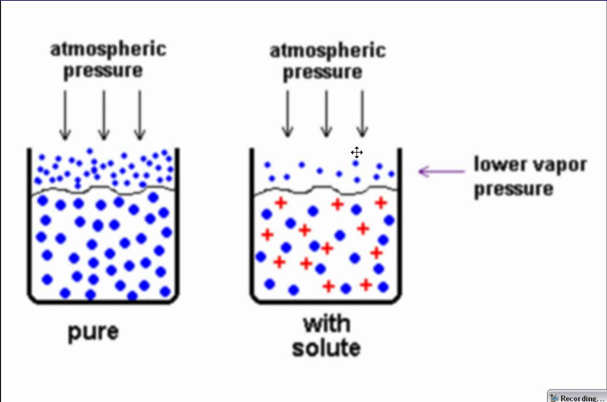
Vapour pressure lowering

- Vapour pressure is created when a small amount of liquid becomes a gas and exerts pressure on the liquid.

- The vapour pressure of a solvent mixed in a solution will always be lower than the vapour pressure of the pure solvent.
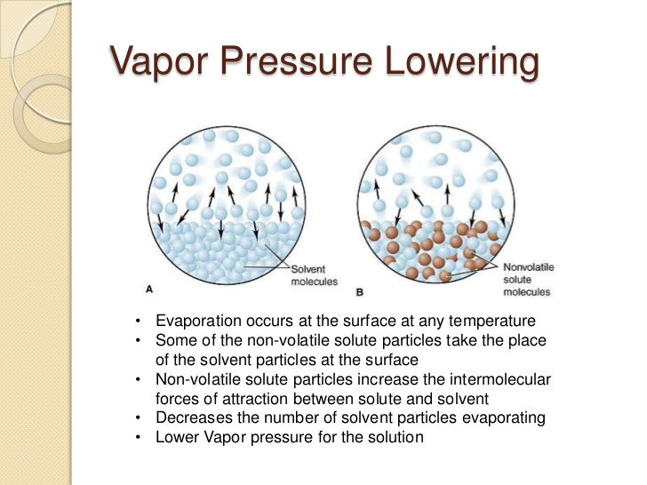
- This is because there is an attraction between the solute and the solvent that makes it harder for the solvent material to escape into the gas phase.
- The stronger the attraction, the lower the vapour pressure above the solution.

- The vapour pressure lowering is directly proportional to the mole fraction of the solute.

Boiling point elevation

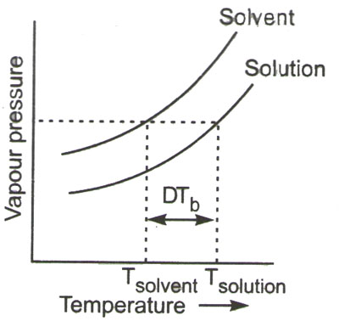
- Boiling point elevation describes the phenomenon that the boiling point of a liquid (a solvent) will be higher when another compound is added, meaning that a solution has a higher boiling point than a pure solvent.
- This happens whenever a non-volatile solute, such as a salt, is added to a pure solvent, such as water.

- The boiling point of a substance is the temperature at which the vapour pressure of the liquid equals the pressure surrounding the liquid and the liquid changes into a vapour.

- The addition of solute causes the vapour pressure to lower, meaning that more heat must be added to get the vapour pressure to equal atmospheric pressure.
- The solution will boil at a higher temperature.

Freezing point depression

- Freezing point depression is the phenomena that describes why adding a solute to a solvent results in the lowering of the freezing point of the solvent.
- When a substance starts to freeze, the molecules slow down due to the decreases in temperature, and the intermolecular forces start to take over.
- The molecules will then arrange themselves in a pattern, and thus turn into a solid.
- For example, as water is cooled to the freezing point, its molecules become slower and hydrogen bonds begin to "stick" more, eventually creating a solid.
- If salt is added to the water, the Na⁺ and Cl⁻ ions attract to the water molecules and interfere with the formation of the large network solid known as ice.
- In order to achieve a solid, the solution must be cooled to an even lower temperature.
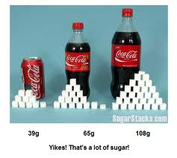
CONCENTATIONS OF SOLUTIONS
- Grams per Litre (g L⁻¹)
$$concentration (g L^{-1})= \frac{grams}{litres} ;c= \frac{g}{L}$$

- Solution concentration can be expressed as the number of grams dissolved in a litre of solution.
- For example, the sucrose concentration in cola drinks is usually 0.106 g mL⁻¹ (106 g L⁻¹).
- Hence a 375 mL can of this drink contains 39.8 g of sugar.

- 20.0 g of potassium nitrate (KNO₃) is dissolved in 250 mL of solution. Determine the concentration in grams per litre (gL⁻¹).

- Percentage Composition by Mass
$$concentration \left(\% composition\right)= \frac{mass of solute (g)}{mass of solution (g)} x 100$$

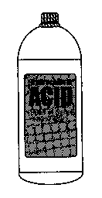
- The percentage composition by mass is the mass of solute in grams dissolved in 100 g of solution
Hydrochloric
ACID
32% w/w

- For example concentrated hydrochloric acid is labelled as 32% w/w. This means that 1.00 kg of this acid solution would contain 320 g of hydrochloric.

- A 2.50 kg sample of sea water was evaporated to dryness and 86.5 g of solids remained. Determine the concentration of the solids as a percentage by mass.

- Parts per Million (ppm)
$$concentration \left(ppm\right)= \frac{mass of solute (mg)}{mass of solution (kg)} = \frac{mass of solute (g)}{mass of solution (g)} x {10}^{6}$$

- This method is used for very dilute solutions.

- The concentration in parts per million is the mass of solute, in milligrams, in one kilogram of solution. This is because 1 mg is one-millionth the mass of 1 kg.
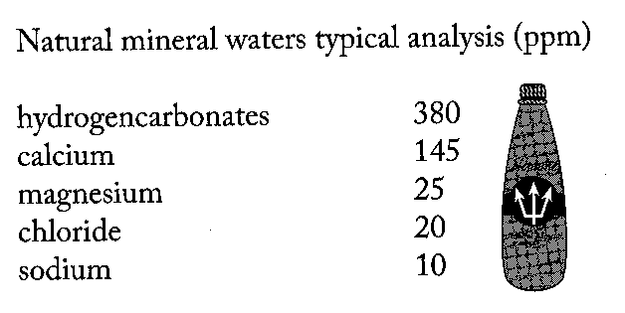
- This unit is often used for very dilute solutions such as the concentration of salt in tap water or impurities/additives in a produce.

- In the 2.50 kg sample of sea water that was evaporated to dryness, 73.4 g was sodium chloride. Calculate the concentration of the sodium chloride in parts per million.

- Moles per Litre (mol L⁻¹ or M)
$$concentration \left(mol L^{-1}\right)= \frac{number of moles of solute \left(mol\right)}{volume of solution (L)} ; c= \frac{n}{V}$$

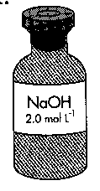
- The concentration of solution in moles per litre indicates the number of moles of solute in a litre of solution.

- The concentration, when expressed as mol L⁻¹, is often referred to as molar concentration or molarity of a solution – denoted by the symbol M. ie 1.0 M HCl is 1.0 mol L⁻¹ HCl.

- A 750 mL bottle of wine is known to contain 87.7 g of alcohol (CH₃CH₂OH). Calculate the concentration in moles per litre.

- A solution of sodium carbonate is made by dissolving 4.65 g of this substance to make up to 250 mL of solution. Calculate the concentration of this solution in
a. moles per litre

b. grams per litre

- The concentration of gold in sea water is approximately 5 x 10⁻⁶ ppm. What mass of gold does this represent per kg of water?

- For conversions between gL⁻¹and mol L⁻¹, the following can be used:
÷ by M

mol L⁻¹

gL⁻¹

x by M

- The concentration of ethanoic acid (acetic acid) in a sample of vinegar is 38.5 gL⁻¹. What is the molarity (moles per litre)? The formula for ethanoic acid is CH₃COOH.

- A salt solution (NaCl) has a concentration of 0.150 mol L⁻¹. What is the concentration in gL⁻¹.

- Calculate the number of moles of sulphuric acid in 150.0 mL of 2.50 mol L⁻¹ solution of sulphuric acid.

- Calculate the concentration in mol L⁻¹, of a silver nitrate solution prepared by dissolving 5.09 g of solid silver nitrate in 250.0 mL of solution.

- Calculate the mass of oxalic acid (H₂C₂O₄.2H₂O) needed to prepare 500.0 mL of 0.02500 mol L⁻¹ oxalic acid solution.

NC 7.2 p312-6 QS 7.2 p316, QS 6.5 p285 # 4, 7, 9

EC 16.7 p145

CONCENTRATION CALCULATIONS

Concentrations of Ions in Solutions
- From the concentration of the solute, it is possible to calculate the concentration of ions present in solution

- In 20.0 mL of 0.40 mol L⁻¹ aluminium nitrate solution, calculate
- the concentration of aluminium and nitrate ions
- the number of moles of aluminium and nitrate ions

- If these three solutions are added together, calculate the final concentration of OH⁻ ions.

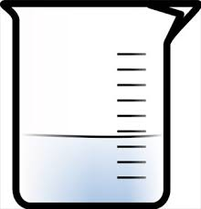



250 mL 200 mL 150 mL
3.0 mol L⁻¹ 10.0 g L⁻¹ 20 % w/w
NaOH Mg(OH)₂ Al(OH)₃

EC 16.8 p145

Dilutions
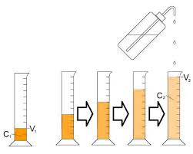
- Dilution does not alter the number of moles of solute present, just the concentration of the solution.
n_{undiluted} = n_{diluted}
c_{u}V_{u} = c_{d}V_{d}
or c₁V₁ = c₂V₂

- What volume of 12.0 mol L⁻¹ HCl is required to prepare 500.0 mL of 2.50 mol L⁻¹ solution?

- 150 mL of 6.0 mol L⁻¹ HNO₃ is added to 500 mL of water. What is the concentration of the new solution?

NC 7.3 p317-8

CALCULATIONS FROM CHEMICAL EQUATIONS INVOLVING SOLUTIONS

Mass of unknown
Mass of known
n = m
M
n = m
M

n = V
22.71
n = V
22.71
from
equation
Volume of unknown (gas)
Moles of known
Moles of unknown
Volume of known (gas)

n = cV
n = cV
Concentration and volume of unknown (solution)
Concentration and volume of known (solution)

PROBLEM SET – Answers p 37
- Calculate the mass of sodium nitrate required to prepare 400.0 mL of sodium nitrate solution with a concentration of 5.0 gL⁻¹.

- A solution is prepared by dissolving 4.50 g of KCl in 250.0 g of water. Calculate the concentration of KCl
a. as a percentage composition
b. in parts per million

- Calculate the mass of silver nitrate contained in 250 mL of 0.215 mol L⁻¹ silver nitrate solution.

- What is the concentration of a sodium carbonate solution in mol L⁻¹, prepared by dissolving 1.32 g of Na₂CO₃ in 250.0 mL of solution?

- What mass of CuSO₄.5H₂O could be obtained if 20.0 mL of 0.525 mol L⁻¹ copper (II) sulfate solution was evaporated to dryness?

- Given 50.0 mL of 0.450 mol L⁻¹ iron (III) nitrate solution, calculate the following:
a. the concentration of Fe³⁺ ions and NO₃⁻ ions.
b. the number of moles of Fe³⁺ ions and NO₃⁻ ions.

- A laboratory assistant is asked to prepare a dilute solution of sulfuric acid from the concentrated acid. What volume of 18 mol L⁻¹ H₂SO₄ is needed to make up 5.0 L of 2.50 mol L⁻¹ sulfuric acid?

- When barium chloride reacts with potassium sulfate solution, solid barium sulfate is produced. The molecular equation is shown below:

BaCl_{2 (aq)} + K₂SO_{4 (aq)} → BaSO_{4 (s)} + 2KCl_{(aq)}

  - Calculate the number of moles of BaCl₂ in 50.0 mL of 0.250 mol L⁻¹ BaCl₂ solution.
  - Now the same number of moles of BaSO₄ are produce so calculate the mass of BaSO₄ produced.
  - Calculate the volume of 0.400 mol L⁻¹ K₂SO₄ solution which would be needed to react with the BaCl₂.

CHEMISTRY 11: Unit 2 - How Much Do You Know.

- Five solutions are prepared by dissolving one mole of each of the salts listed below in one litre of water. Which solution would contain the LEAST number of ions?
  - ammonium phosphate
  - calcium hydrogen carbonate
  - aluminium nitrate
  - sodium sulfate
  - potassium chloride

- 0.40 moles of iron III sulfate were dissolved in 4.0 L of water. Which of the following statements is TRUE?
  - 250 mL of solution contains 0.10 moles of Fe³⁺_{(aq)} ions.
  - The concentration of SO₄⁻²_{(aq)} ions is 0.30 mol L⁻¹.
  - The iron (III) sulfate is 0.2 mol L⁻¹.
  - The concentration of Fe³⁺_{(aq)} ions is 0.10 mol L⁻¹.
  - 800 mL of solution contains 0.12 moles of SO₄²⁻_{(aq)} ions.

- Which volume of 5.0 M K₂CrO₄ solution contains 0.400 mole of K₂CrO₄?
  - 0.080 L
  - 0.80 L
  - 2.0 L
  - 6.0 L
  - 12.0 L

- 2.00 g of sodium hydroxide was dissolved in a little water and more water was added to make a total volume of 50 mL. What is the concentration of this solution?
  - 0.05 mol L⁻¹
  - 0.10 mol L⁻¹
  - 0.50 mol L⁻¹
  - 1.00 mol L⁻¹
  - 5.00 mol L⁻¹

- If 111 g of CaCl₂ are dissolved in enough water to make 1000 mL of solution, what are the concentrations of the ions?
  - 1.0 mol L⁻¹ Ca²⁺ and 1.0 mol L⁻¹ Cl⁻
  - 2.0 mol L⁻¹ Ca²⁺ and 1.0 mol L⁻¹ Cl⁻
  - 1.0 mol L⁻¹ Ca²⁺ and 2.0 mol L⁻¹ Cl⁻
  - 0.1 mol L⁻¹ Ca²⁺ and 0.2 mol L⁻¹ Cl⁻
  - 0.01 mol L⁻¹ Ca²⁺ and 0.02 mol L⁻¹ Cl⁻

- The molarity of a solution may be defined as
  - moles of solute per mole of solvent
  - moles of solute per litre of solution
  - moles of solution per mole of solute
  - grams of solute per litre of solution
  - grams of solute per grams of solution

- Which of the following statements correctly describes a 0.1 mol L⁻¹ solution of chromium III sulfate?
  - The solution contains 0.1 moles of Cr³⁺ _{(aq)} ion in 1.0 litres of solution.
  - The solution contains 2 moles of Cr³⁺_{(aq)} ion in 1.0 litre of solution.
  - The solution contains 1.5 moles of SO₄²⁻_{(aq)} ion in 2.0 litres of solution.
  - The solution contains 0.9 moles of SO₄²⁻_{(aq)} ion in 3.0 litres of solution.
  - The solution contains 0.4 moles of Cr³⁺_{(aq)} ion in 1.0 litre of solution.

- A 100 mL sample of 1.0 mol L⁻¹ solution of BaCl₂ contains:
  - 0.1 mol of Ba²⁺ and 0.1 mol of Cl⁻.
  - 0.1 mol of Ba²⁺ and 0.2 mol of Cl⁻.
  - 0.1 mol of H₂O and 0.2 mol of BaCl₂
  - 1.0 mol of Ba²⁺ and 2.0 mol of Cl⁻.
  - 0.2 mol of Ba²⁺ and 0.1 mol of Cl⁻.

- 7.30 g of hydrogen chloride were dissolved in water and the volume made up to 500 mL. The molar concentration of this solution is:
  - 0.1 mol L⁻¹
  - 0.2 mol L⁻¹
  - 0.4 mol L⁻¹
  - 1.0 mol L⁻¹
  - 2.0 mol L⁻¹

- In a mixture of water and sugar, the sugar is known as the:
  - solute
  - solvent
  - solution
  - filtrate
  - none of the above

- Which of the following statements is FALSE? The difference between a compound and a solution is that a:
  - compound is chemically combined and a solution is not.
  - compound is easier to separate physically than a solution.
  - solution can be separated by distillation and a compound cannot.
  - solution can be separated by evaporation and a compound cannot.
  - compound is homogeneous and a solution is not.

- If some salt, NaCl, is dissolved in water, which one of the following statements is TRUE?
  - The vapour pressure, melting point and boiling point of the solution are all higher than for pure water.
  - The vapour pressure of the solution is higher than water; the melting and boiling points are lower.
  - The vapour pressure and melting point of the solution are lower than water; the boiling point is higher.
  - The vapour pressure and boiling point of the solution are higher; the melting point is lower.
  - The vapour pressure, melting point and boiling point of the solution are all lower than for pure water.

- Which of the following statements concerning the solubility of a gas in a liquid is FALSE?
  - The energy of a gas is lower when it is dissolved in a liquid.
  - The randomness of a gas is decreased when it is dissolved in a liquid.
  - Warming a saturated solution of a gas dissolved in a liquid causes bubbles of gas to appear on the sides of the container.
  - The amount of gas which dissolves in water increases as the temperature increases.
  - Fish and other aquatic life depend on the oxygen dissolved in the sea water.

- Sodium carbonate and ammonium chloride were mixed in water to form solution A. Potassium nitrate and barium chloride were mixed in water to form solution B. When solution A and B were mixed, a white precipitate formed. The precipitate was:
  - barium nitrate
  - barium carbonate
  - barium nitrate and barium carbonate
  - ammonium carbonate
  - ammonium chloride and ammonium carbonate.

- A substance Y, when dissolved in water, gives a precipitate with sodium carbonate solution and with sodium sulfate solution, but gives no reaction with sodium chloride. The positive ion present in Y could be:
  - Al³⁺
  - Zn²⁺
  - Mg²⁺
  - Ba²⁺
  - Na⁺

- When 1.0 mol L⁻¹ aqueous solutions of the substances in each of the following pairs are mixed, in which case will precipitates be formed?
I AgNO₃ and NaCl
II CaCl₂ and (NH₄)₂CO₃
III Ba(NO₃)₂ and K₂SO₄
IV KNO₃ and MgCl₂

  - I, II and III only
  - I and III only
  - II and IV only
  - I and II only
  - II, III and IV only

- Which of the following equations correctly expresses the dissociation of calcium chloride in water?
  - CaCl_{2 (s)} + H₂O → CaCl_{2 (aq)}
  - CaCl_{2 (s)} → CaCl_{2 (aq)}
  - CaCl_{2 (s)} + H₂O → CaCl⁺ _{(aq)} + Cl⁻_{(aq)}
  - CaCl_{2 (s)} → CaCl⁺ _{(aq)} + Cl⁻_{(aq)}
  - CaCl_{2 (s)} → Ca²⁺_{(aq)} + 2Cl⁻ _{(aq)}

- What would be observed after an aqueous solution of iron (III) chloride was added to an aqueous solution of silver nitrate?
  - A brown precipitate in a colourless solution.
  - A metallic precipitate in a pale green solution.
  - An orange-brown precipitate and a foul smelling gas is evolved.
  - No reaction visible with the naked eye.
  - A white precipitate settled out of a yellow/brown solution.

- Which one of the following would show the greatest electrical conductivity?
  - 10 mL of 0.2 mol L⁻¹ HCl
  - 30 mL of 0.1 mol L⁻¹ HCl
  - 10 mL of 0.4 mol L⁻¹ CH₃COOH
  - 30 mL of 0.2 mol L⁻¹ CH₃COOH
  - 10 mL of 0.1 mol L⁻¹ CH₃COOH

- Which of the following would NOT conduct an electric current?
I a crystal of potassium bromide
II molten sulfur
III molten lithium
IV a crystal of iodine
- All of I, II, III, IV
- I and IV only
- I, II and IV only
- II and III only
- II and IV only

CALCULATIONS:

- When the contents of a 375 mL can of cool drink were evaporate to dryness, 51.2 g of sugar remained. Calculate the concentration of original sugar in:

  - grams per litre
  - moles per litre, given the chemical formula of sugar is C₆H₁₂O₆. (2 marks)

- Calculate the number of moles of solute in the following:

  - 2.50 L of 3.00 M CaCl_{2 (aq)}
  - 15.50 mL of 0.105 M HNO_{3 (aq)} (2 marks)

- Determine the mass of solute in the following solutions:

  - 250 mL of 0.050 M Na₂CO₃.
  - 50 mL of 0.500 M CuSO₄.5H₂O (3 marks)

- If solutions of MgCl₂ and NaOH are mixed, a precipitate of Mg(OH)₂ is formed according to the following equation:

MgCl_{2 (aq)} + 2NaOH _{(aq)} → Mg(OH)_{2 (s)} + 2NaCl_{(aq)}
If 10.0 mL of 0.50 M MgCl₂ reacts, calculate the following:
- the mass of Mg(OH)₂ produced
- the volume of 0.240 M NaOH needed to react with it. (3 marks)

- Write balanced ionic equations for the following:
  - Mixing solutions of lead nitrate and ammonium sulphate.
  - Mixing solutions of silver nitrate and sodium bromide
  - Adding dilute HCl to solid CuCO₃
  - Adding dilute H₂SO₄ to Mg. (4 marks)

ANSWERS
1. e 2. b 3. a 4. e 5.c 6.b 7. d 8. b 9. c 10. a 11. b 12. c
13. d 14. b 15. d 16. a 17. e 18. e 19.a 20. c
21. a. 136.5 g/L b. 0.758 mol/L
22. a. 7.5 mol b. 1.62 x 10⁻³ mol
23. a. 1.32 g b. 6.24 6
24. a. 0.292 g b. 0.042 L
25. a. Pb²⁺_{(aq)} + SO₄²⁻_{(aq)} PbSO_{4 (s)}
b. Ag⁺_{(aq)} + Br⁻_{(aq)} AgBr _{(s)}
c. 2H⁺_{(aq)} + CuCO_{3(s)} Cu²⁺_{(aq)} + CO_{2(g)} + H₂O_{(l)}
d. 2H⁺_{(aq)} + Mg_{(s)} Mg²⁺_{(aq)} + H₂O_{(g)}
Solutions Summary
- Know definitions for solutions e.g. solute, solvent, saturated, etc.
- Concentration: Solubility in water. e.g. NaCl 36g per 100 mL water
Solubility expressed as grams of solute per grams or volume of water
e.g. NaCl 36 g per 100 g water = 36g/mL = 360 g L⁻¹
- To dissolve – intermolecular electrostatic attractive force between solute broken
  - Intermolecular electrostatic attractive force between water broken
  - Intermolecular electrostatic attractive force between solute and water made
- Factors affecting solubility
  - Nature of solute – polar or non-polar (polar have a negative and positive end to molecule)
  - Temperature – solutes generally more soluble at higher temps, gasses less soluble
- Aqueous solutions occur when a solute dissolves in water
- Electrolytes
  - Electrolytes produce ions when dissolve in water – conduct electricity
  - Strong electrolytes fully form ions – strong acids and bases and soluble ionic solids
Ionic: NaCl_{(aq)} → Na⁺_{(aq)} + Cl⁻_{(aq)} Strong acid (molecule): HCl_{(aq)} → H⁺_{(aq)} + Cl⁻_{(aq)}
  - Weak electrolytes partially form ions, rest stay as molecules e.g. weak acids & bases
Weak acid: CH₃COOH_{(aq)} ⇋ CH₃COO⁻_{(aq)} + H⁺_{(aq)} Weak base: NH_{3 (aq)} + H₂O_{(aq)} ⇋ NH₄⁺ _{(aq)} + OH⁻_{(aq)}
  - Non-electrolyte do not produce ions e.g. not an acid or base
- Cations – postive ions and anions negative ions
- Dissociation – ionic compounds forming ions e.g. NaCl_{(s)} Na⁺_{(aq)} + Cl⁻_{(aq)}
- Ionisation – molecular substance dissolved in water e.g.
- strong HCl_{(g)} H⁺_{(aq)} + Cl⁻_{(aq)}
- weak HF_{(aq)} ⇋ H⁺_{(aq)} + F⁻_{(aq)}
- Solubility rules and reactions
  - Precipitate – solid formed between two solutions
  - Can form only between a positve ion of one solution and negative ion of another.
  - Look up solubility table in data sheet to see if precipitate will form
- Precipitate colour usually comes from one of the ions – look up colour chart in data sheet.
  - identify and list ions present
  - write formula of possible precipitates by combing oppositely charged ions
  - check solubility table to determin solubility of substances.
  - write balanced molecular equation (ionic equations next unit)
- Ionic equations – become familiar with these
;

- Concentration units - (i) grams per litre, gL⁻¹

(ii) percentage composition by mass

(iii) parts per million (ppm)

(iv) moles per litre,

16. Dilutions: c₁V₁ = c₂V₂

EXTRA QUESTION ON PAGE 38

PROBLEM SET

  - 30 g NaCl in 100 g of H₂O unsaturated – less than 36g/100g
  - 38 g NaCl in 100 g of H₂O supersaturated – over 36g/100g
  - 36 g NaCl in 100 g of H₂O saturated – exactly 36g/100g
  - 20 g NaCl in 50 g of H₂O supersaturated – 40g/100g
  - 9 g NaCl in 25 g of H₂O saturated – 36g/100g
  - 25 g NaCl in 80 g of H₂O unsaturated – 31.5g/100g
- Prepare a saturated solution at a higher temperature than 25⁰C and then cool it (very slowly) back to 25⁰C
- Add the crystal to the solution
  - If unsaturated the crystal will dissolve
  - If saturated no change
  - If supersaturated then more crystals will form as excess salt crystallises out of solution
PROBLEM SET

  - Potassium chloride KCl_{(s)} → K⁺_{(aq)} + Cl⁻_{(aq)}
  - Calcium nitrate Ca(NO₃)_{2 (s)} → Ca²⁺_{(aq)} + 2NO₃⁻_{(aq)}
  - Silver chloride AgCl_{(s)} → Ag⁺_{(aq)} + Cl⁻_{(aq)}
  - Iron (II) nitrate Fe(NO₃)_{2 (s)} → Fe²⁺_{(aq)} + 2NO₃⁻_{(aq)}
  - Magnesium bromide MgBr_{2 (s)} → Mg²⁺_{(aq)} + 2Br⁻_{(aq)}
  - Iron (III) sulfate Fe₂(SO₄)_{3 (s)} → 2Fe³⁺_{(aq)} + 3SO₄²⁻ _{(aq)}
  - Ammonium Ferrous Sulfate (NH₄)₂Fe(SO₄)₂ _{(s)} → 2NH₄⁺ _{(aq)} + Fe²⁺_{(aq)} + 2SO₄²⁻ _{(aq)}
  - aluminium sulfate Al₂(SO₄)_{3 (s)} → 2Al⁺³_{(aq)} + 3SO₄²⁻ _{(aq)}

  - magnesium nitrate Mg(NO₃)₂ strong
  - ammonia gas NH₃ weak NH_{3(aq)} + H₂O_{(l)} ⇋ NH₄⁺_{(aq)} + OH⁻_{(aq)}
  - Benzene: C₆H₆ non-electrolyte
  - Lithium hydroxide LiOH strong
  - Ethanoic acid: CH₃COOH weak CH₃COOH _{(aq)} ⇋ H⁺_{(aq)} + CH₃COO⁻_{(aq}
  - Ammonium chloride NH₄Cl strong

  - potassium sulfate: high
  - HI low
  - Methanol: CH₃OH zero
  - NaOH high
  - Ammonia low
  - Glucose: C₆H₁₂O₆ zero
  - BaSO₄ (virtually insoluble) low
  - CH₃COOH (ethanoic acid) low

  - HCl_{(g)} → H⁺_{(aq)} + Cl⁻ _{(aq)}
  - HNO_{3(l)} → H⁺_{(aq)} + NO₃⁻ _{(aq)}
  - HClO_{4(l)} → H⁺_{(aq)} + ClO₄⁻ _{(aq)}
  - H₂SO_{4(l)} → 2H⁺_{(aq)} + SO₄⁻² _{(aq)} or H₂SO_{4(l)} → H⁺_{(aq)} + HSO₄⁻ _{(aq)}
  - HBr(g) → H⁺_{(aq)} + Br⁻_{(aq)}

  - HF HF _{(aq)} ⇋ H⁺_{(aq)} + F⁻ _{(aq)}
  - H₂SO₃ H₂SO_{3 (aq)} ⇋ H⁺_{(aq)} + HSO₃⁻ _{(aq)}
  - Oxalic acid: H₂C₂O₄ H₂C₂O₄ _{(aq)} ⇋ H⁺_{(aq)} + HC₂O₄⁻ _{(aq)}
  - Nitrous acid: HNO₂ HNO_{2 (aq)} ⇋ H⁺_{(aq)} + NO₂⁻ _{(aq)}

  - sodium hydroxide strong NaOH_{(s)} → Na⁺_{(aq)} + OH⁻ _{(aq)}
  - ethanoic acid weak CH₃COOH _{(aq)} ⇋ H⁺ _{(aq)} + CH₃COO⁻ _{(aq)}
  - copper (II) ethanoate strong Cu(CH₃COO)_{2 (aq)} → Cu²⁺ _{(aq)} + 2CH₃COO⁻ _{(aq)}
  - ethanol (C₂H₅OH) no reaction
  - iron (III) chloride strong FeCl_{3 (s)} → Fe³⁺_{(aq)} + 3Cl – _{(aq)}
  - sucrose (C₁₂H₂₂O₁₁) no reaction
  - ethane (CH₄) no reaction
  - hydrogen sulfide weak H₂S _{(aq)} ⇋ H⁺ _{(aq)} + HS⁻ _{(aq)}
  - chloroform (CHCl₃) no reaction
  - potassium dichromate strong K₂Cr₂O_{7 (s)} → 2K⁺ _{(aq)} + Cr₂O₇²⁻ _{(aq)}
  - nitric acid strong HNO_{3 (l)} → H⁺_{(aq)} + NO₃⁻_{(aq)}
  - calcium hydroxide strong Ca(OH)_{2 (s)} → Ca²⁺_{(aq)} + 2OH⁻_{(aq)}
  - ammonium sulfate strong (NH₄)₂SO_{4 (s)} → 2NH₄⁺_{(aq)} + SO₄⁻²_{(aq)}

  - HCl is a strong electrolyte as it is a strong acid. Strong electrolytes completely ionise to form ions.
  - In solid form, NaCl is an ionic lattice with strong bonds so doesn’t contain free ions, it’s not until it is in aqueous state that when it breaks into ions that there are free ions to conduct electricity
  - HCl is a strong electrolyte so mostly ions in solution. HF is a weak electrolyte so only partly ionised.
  - Silver chloride is insoluble in water so doesn’t have a high concentration of ions.
- Copper nitrate is a strong electrolyte so exists as ions in solution.(Very soluble).

- When the two are combined you get the following equation:
NH_{3 (aq)} + CH₃COOH _{(aq)} → NH₄CH₃COO _{(aq)}
base + acid salt
and ammonium ethanoate is an ionic compound and a strong electrolyte
NH₄CH₃COO_{(aq)} NH₄⁺ _{(aq)} + CH₃COO⁻ _{(aq)}

PROBLEM SET

  - ZnCO_{3 (s)}
  - Fe(OH)_{2 (s)}
  - PbCl_{2 (s)}
  - CaSO_{4 (s)} slightly soluble
  - BaSO_{4 (s)}

  - Ag⁺_{(aq)} + Br⁻_{(aq)} → AgBr_{(s)}
  - Pb²⁺_{(aq)} + SO₄²⁻_{(aq)} → PbSO_{4 (s)}
  - 3Ca²⁺_{(aq)} + 2PO₄³⁻_{(aq)} → Ca₃(PO₄)_{2 (s)}
  - Zn²⁺_{(aq)} + 2OH⁻_{(aq)} → Zn(OH)_{2 (s)}
  - 2Fe³⁺_{(aq)} + 3CO₃²⁻_{(aq)} → Fe₂(CO₃)_{3 (s)}
  - Zn²⁺_{(aq)} + CrO₄²⁻_{(aq)} → ZnCrO_{4 (s)}

  - Brown solution is FeCl_{3 (aq)} and only ppt formed from Na₂CO_{3 (aq)}
  - ppt is either MgCO₃ or PbCO₃ so Na₂CO_{3(aq)} mixed with either MgI_{2(aq)} or Pb(NO₃)_{2(aq)}
  - FeSO_{4 (aq)} with Na₂CO_{3 (aq)} as only carbonate will form ppt
  - CuSO_{4 (aq)} with carbonate to product a green ppt, so Na₂CO_{3 (aq)}
  - lead iodide is yellow: Pb(NO₃)_{2 (aq)} + MgI_{2 (aq)} → PbI_{2 (s)}
  - CoCl_{2 (aq)} and only colourless solution to form ppt is Na₂CO_{3 (aq)}

  - Precipitation reaction? YES
Ionic equation: Ca²⁺_{(aq)} + CO₃²⁻_{(aq)} → CaCO_{3 (s)}
Observation: two colourless solutions produce a white ppt and a colourless
solution

  - Precipitation reaction? NO
Observation: two colourless solutions are mixed to produce no visible reaction

  - Precipitation reaction? YES
Ionic equation: Ca²⁺_{(aq)} + 2OH⁻_{(aq)} → Ca(OH)_{2 (s)}
Observation: two colourless solutions produce a white ppt and a colourless
Solution

  - Precipitation reaction? YES
Ionic equation: Cu²⁺_{(aq)} + 2OH⁻_{(aq)} → Cu(OH)_{2 (s)}
Observation: a blue and colourless solutions produce a blue ppt and a
colourless solution
  - Precipitation reaction? YES
Ionic equation: Cr³⁺_{(aq)} + 3OH⁻_{(aq)} → Cr(OH)_{3 (s)}
Observation: a green and colourless solutions produce a green ppt and a
colourless solution

  - Precipitation reaction? YES
Ionic equation: Co²⁺_{(aq)} + 2OH⁻_{(aq)} → Co(OH)_{2 (s)}
Observation: a pink and colourless solutions produce a pink-red ppt and a
colourless solution

  - Precipitation reaction? YES YES
Ionic equation: Ba²⁺_{(aq)} + 2OH⁻_{(aq)} + Mg²⁺_{(aq)} + SO₄²⁻_{(aq)} → BaSO_{4(s)} + Mg(OH)_{2 (s)}
Observation: two colourless solutions produce two white ppt’s

  - CoCO₃ cobalt nitrate or cobalt chloride and sodium carbonate
  - Ni(OH)₂ nickel nitrate and sodium hydroxide
  - PbCl₂ sodium chloride and lead nitrate
  - Cr(OH)₃ chromium nitrate and sodium hydroxide
  - BaSO₄ barium nitrate and sodium sulphate

- Lead (II) nitrate and Calcium nitrate. Formulas Pb(NO₃)₂ and Ca(NO₃)₂
NaBr Pb(NO₃)₂ + NaBr → PbBr_{2 (s)} white ppt
Ca(NO₃)₂ + NaBr → no reaction
- Silver nitrate and calcium nitrate. Formulas AgNO₃ and Ca(NO₃)₂
NaBr AgNO₃ + NaBr → AgBr _{(s)} white ppt
Ca(NO₃)₂ + NaBr → no reaction

- Iron (II) nitrate and iron (III) nitrate. Formulas Fe(NO₃)₂ and Fe(NO₃)₃
pale green pale brown
Na₂CO₃ Fe(NO₃)₂ + Na₂CO₃ → FeCO_{3 (s)} pale green ppt
Fe(NO₃)₃ + Na₂CO₃ → Fe₂(CO₃)_{3 (s)} pale brown ppt
- Sodium carbonate and potassium carbonate. Formulas Na₂CO₃ and K₂CO₃
Can’t tell apart with solutions given
- Potassium hydroxide and potassium sulphate. Formulas KOH and K₂SO₄
Mg(NO₃)₂ KOH + Mg(NO₃)₂ → Mg(OH)_{2 (s)} white ppt
[Also Ba(NO₃)₂] K₂SO₄ + Mg(NO₃)₂ → no reaction

- Magnesium chloride and magnesium iodide Formulas MgCl₂ and MgI₂
Pb(NO₃)₂ MgCl₂ + Pb(NO₃)₂ → PbCl_{2 (s)} white ppt slight
MgI₂ + Pb(NO₃)₂ → PbI_{2 (s)} yellow ppt

PROBLEM SET

- 1.68g

EXTRA QUESTIONS – Answers p 42

- Give two solutions that could produce the following solids:
  - calcium hydroxide

  - lead sulfate

  - iron III carbonate

  - barium sulfate (without using a solution with sodium, potassium or lithium)

- During an experiment to investigate precipitation reactions. Two chemistry students mixed the following pairs of solutions. In some cases they saw a precipitation reaction and observed the mixture turn cloudy. For each of the situations where a precipitation reaction is expected write a precipitation equation to show this and note the colour of the precipitate that forms.

a. CuSO₄ _{(aq)} and NaOH _{(aq)}

b. Al(NO₃) ₃ _{(aq)} and K₂CO₃ _{(aq)}

c. AgNO₃ _{(aq)} and FeSO₄ _{(aq)}

d. MnCl₂ _{(aq)} and K₂CO₃ _{(aq)}

e. NiSO₄ _{(aq)} and MgCl₂ _{(aq)}

f. Cr₂(SO₄)₃ _{(aq)} and NaOH _{(aq)}

NB: Chromium is an amphoteric metal which will dissolve in a hydroxide solution with a high concentration forming a complex ion. Amphoteric metals are no longer part of the course so assume dilute hydroxide solutions.

3. Two chemistry students made mixtures of some of the following 0.5 mol L⁻¹ solutions.
CuSO₄ _{(aq)} Pb(NO₃) ₂ _{(aq)} MnCl₂ _{(aq)} Fe(NO₃) ₃ _{(aq)} K₂CO₃ _{(aq)} Cr(NO₃) ₃ _{(aq)} FeCl₂ _{(aq)} NaI _{(aq)}

They did this by combining ten drops of any two of these solutions in a small test tube. They recorded the observations listed below for each experiment:
What pairs of solutions were mixed in order to observe each of the recorded changes?

a. Two colourless solutions produced a bright yellow precipitate.

b. A blue solution and a colourless solution form a green precipitate.

c. A white precipitate formed from a colourless solution and a blue solution.

d. Two solutions produced a pale pink precipitate.

4. You are given four different solutions in unlabelled containers (listed below). Describe how you could use precipitation reactions using the labelled reagents listed below to identify each of the unlabelled reagents. The usual laboratory apparatus is at your disposal.

Unlabelled Solutions:
Ca(NO₃)₂ _{(aq)} Mg(NO₃) ₂ _{(aq)} Fe(NO₃) ₂ _{(aq)} Ba(NO₃) ₂ _{(aq)}

Labelled Reagents:
Na₂CO₃ _{(aq)} Na₂SO₄ _{(aq)} NaCl _{(aq)} NaOH _{(aq)}

- Calculate the number of moles of sulphuric acid in 150.0 mL 2.50 mol L⁻¹ H₂SO₄ solution.

- Calculate the concentration in mol L⁻¹, of a silver nitrate solution prepared by dissolving 5.09 g of AgNO₃ in 250.0 mL of solution.

- Calculate the mass of oxalic acid (H₂C₂O₄.2H₂O) needed to prepare 500.0 mL of 0.02500 mol L⁻¹ oxalic acid solution.

- 250 mL of a sodium chloride solution acid contains 10.0 g solid sodium chloride. What is the concentration of the sodium chloride solution in mol L⁻¹?

- 200.0 g of water contains 20.0 grams of copper sulfate. What is the concentration of the solute in percentage by mass?

- Fluorine is added to drinking water to help in dental care, one part per million being the usual dose. However if larger doses are added, e.g. 3 parts per million, it can be harmful causing mottled, discolouration of teeth enamel and damaging deposits of fluoride in bones, known as fluorosis. If a chemist found that 5.0 L of water contained 0.030 g of fluorine, would the water be fit to drink?

- Calculate the mass of potassium carbonate in 200.0 mL of a solution if the concentration is 2.00 M.

- Determine the concentration in mol L⁻¹ of the two solutions described here:
a. A 2.11 L potassium permanganate solution that contains 0.726 mol of potassium permanganate solution.
b. 56.79 mL of phosphoric acid solution that contains 8.98 x 10⁻² mol of phosphoric acid.

- The concentration of two different solutions is outlined here. Determine the concentration of each of these solutions in mol L⁻¹, g L⁻¹, ppm and % by mass.

a. A solution with a total volume of 4.375 L contains 122 g of sodium carbonate. The total mass of this solution is 4.46 kg.

b. A primary standard of ammonium iron (II) sulfate prepared by dissolving 6.970 g of
(NH₄) ₂Fe(SO₄) ₂.6H₂O in a small amount of water and making the solution up to 250.0 mL in a volumetric flask. The 250.0 mL solution has a mass of 254.0 g.

Problem Set

- various answers:
  - calcium nitrate and barium hydroxide
  - lead nitrate and sodium sulfate
  - Iron III chloride and potassium carbonate
  - barium hydroxide and ammonium sulphate

a. Cu²⁺_{(aq)} + 2OH⁻_{(aq)} → Cu(OH)_{2 (s)} blue
b. 2Al³⁺_{(aq)} + 3CO₃²⁻_{(aq)} → Al₂(CO₃)_{3 (s)} white
c. 2Ag⁺_{(aq)} + SO₄²⁻_{(aq)} → Ag₂SO_{4 (s)} white
d. Mn²⁺_{(aq)} + CO₃²⁻_{(aq)} → MnCO_{3 (s)} pale pink
e. NR
f. Cr³⁺_{(aq)} + 3OH⁻_{(aq)} → Cr(OH)_{3 (s)} deep-green
3.
a. Pb(NO₃)_{2 (aq)} and NaI _{(aq)}
b. CuSO₄ _{(aq)} and K₂CO₃ _{(aq)}
c. CuSO₄ _{(aq)} and Pb(NO₃) ₂ _{(aq)}
d. MnCl₂ _{(aq)} and K₂CO₃ _{(aq)}
4.
the following is ONE possible method, there are others

Test 1: Add NaOH_{(aq)} to each
Ca(NO₃)₂ _{(aq)} → white ppt
Mg(NO₃) ₂ _{(aq)} → white ppt
Fe(NO₃) ₂ _{(aq)} → green ppt
Ba(NO₃) ₂ _{(aq)} → NR

now we need to separate Ca(NO₃)_{2 (aq)} and Mg(NO₃)_{2 (aq)} as both give a white ppt.

Test 2: Add Na₂SO_{4 (aq)}

Ca(NO₃)_{2 (aq)} → white ppt

Mg(NO₃)_{2 (aq)} → NR

n(H₂SO₄) = c x V = 0.150 x 2.50
= 0.375 mol (3s.f.)

n (AgNO₃) = m = 5.09 = 0.02996 mol
M 169.9

Therefore c(AgNO₃) = n = 0.02996 = 0.120 mol L⁻¹ (3s.f.)
V 0.25000

n (H₂C₂O₄.2H₂O) = c x V = 0.025 x 0.500 = 0.01250 mol
Therefore
m(H₂C₂O₄.2H₂O) = n x M = 0.01250 x 126.068 = 1.58 g (3s.f.)

n (NaCl) = m = 10 = 0.1711 mol
M 58.44
c(NaCl) = n = 0.1711 = 0.684 mol L⁻¹ (3s.f.)
V 0.25

m_{g} = 20 g CuSO₄
m_{t} = 200 g
c = 10.0% (3s.f.)

m_{g} = 0.03 g
m_{t} = 5000 + 0.03
= 5000.03 g c = 6.00 ppm
so no, unfit to drink

n(K₂CO₃) = cV m(K₂CO₃) = n x M
= 2 x 0.2 = 0.4 x 138.21
= 0.4 mol = 55.3 g (3s.f.)

a. V(KMnO₄) = 2.11 L
n(KMnO₄) = 0.726 mol c(KMnO₄) = 0.344 mol L⁻¹

b. V(H₃PO₄) = 0.05679 mL
n(H₃PO₄) = 8.98 x 10⁻² mol c(H₃PO₄) = 1.58 mol L⁻¹

Mol L⁻¹  V = 4.375 L mol  M(Na₂CO₃)  = 105.99 g mol⁻¹ c = 0.263 mol L⁻¹ | g L⁻¹  m = 122  V = 4.375 L  c = 27.9 g L⁻¹
ppm  m_{g} = 122 g  m_{t} = 4460 g  c = 2.74 x 10⁴ ppm | % by mass  m_{g} = 122 g  m_{t} = 4460 g  c = 2.74%

b.
Mol L⁻¹  V = 0.250 L mol  M( (NH₄)₂Fe(SO₄)₂.6H₂O)  = 392.15 g mol⁻¹ c = 7.11 x 10⁻² mol L⁻¹ | g L⁻¹  m = 6.970 g  V = 0.250 L  c = 27.9 g L⁻¹
ppm  m_{g} = 6.97 g  m_{t} = 254 g  c = 2.74 x 10⁴ ppm | % by mass  m_{g} = 6.970 g  m_{t} = 254 g  c = 2.74%

